Russian Language and Culture
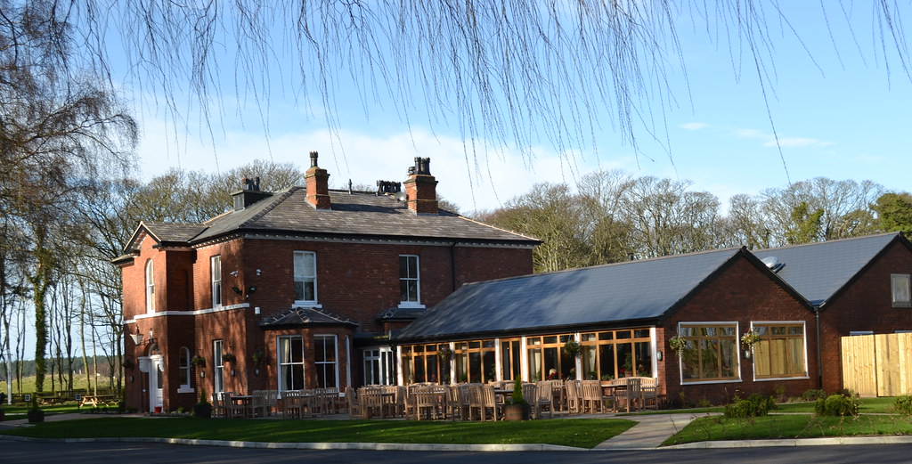
Winter Study Day 2022

Ho, ho, ho……and so…… once again on to The Sparrowhawk for a fabulous lunch and a good chat about all things Russian over dessert and coffee.

All this was after a chat in Russian about `If Money Was no Object, Where Would You Spend Christmas?` A thanks must be given to our fortnightly host Pauline, who lends us her cosy home and provides tea/coffee with lovely biscuits.

Today, we were also joined by a new friend Derek Aitken, who has both studied Russian at university level and taught the subject for twenty years. His experience and knowledge of the language proved to be so useful as he fielded the usual complex grammar questions associated with this fiendish language.

Personally, I feel very happy at the moment with the development of the group and look forward to more discussions which, at the moment, feel like taking off from the edge of a cliff…….but….heigh ho!!

Chris Devereux,
Facilitator

