Russian Language and Culture
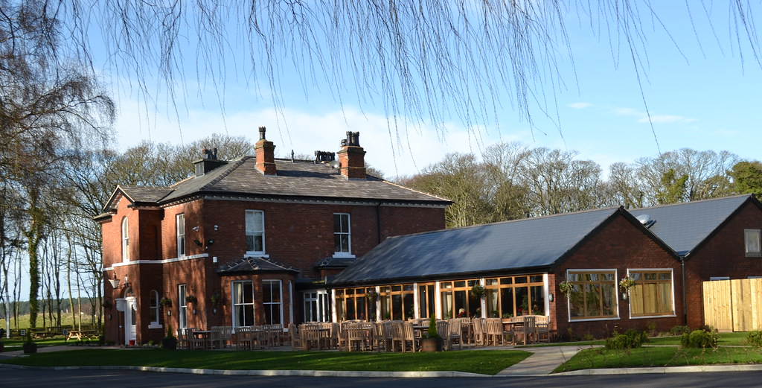
Winter Study Day

On Friday 6th December, our very special little Russian Language and Culture Group, met at the Sparrowhawk, near Formby, for a very enjoyable day out. We all met for coffee and tea in the garden room and then had great fun reading and translating three Christmas Carols. It was not long before we had worked out what the carols where and when we had all finished our work, I suggested that we have a `sing song` as well. Chris sang the main tune in Russian and we all joined in with various harmonies…... at least some of the notes harmonised we think!! Anyway, it was great fun and we all enjoyed the process.
We then moved into the main part of the building for the cultural talk, given by myself, Jannice Crawford , on the history of the area and the buildings. It was really interesting to find out that the first settlement on the footprint of this place went back 4000 years to the Bronze Age. The only Russian connection was vague but nevertheless a connection, as in the 9th century Norsemen who had a settlement on the site and developed the woodlands and forests as well as the farmland and lakes. The Norsemen it is known travelled across Russia to China and were influenced by the Dragon Heads which of course they used on the bow of their long boats and on other Viking buildings. These were used to symbolically ward off evil spirits. Various buildings had been developed over the centuries but eventually Formby Hall and the Dower House became established and still remain here today. One of our group who had joined us for the day, also told us that the Liberal Leader Jeremy Thorpe had held his political meetings there with many other Liberal Leaders and MPs.
After the talk we ordered lunch and enjoyed good fellowship and friendship. The food was delicious and it was a time for catching up and sharing ideas with plenty of Christmas spirit. We now have a short break for the holidays and will start our new term on January 9th. I know we are all looking forward to continuing learning Russian, reading Chekhov plays and all the different aspects of the Russian Culture

Jannice Crawford

